**Project Planning Phase**

**Project Planning Template (Product Backlog, Sprint Planning, Stories, Story points)**

|  |  |
| --- | --- |
| **Date** | 22 October 2022 |
| **Team ID** | PNT2022TMID17801 |
| **Project Name** | Visualizing And Predicting Heart Diseases with An Interactive Dash Board |
| **Maximum Marks** | 8 Marks |

**Product Backlog, Sprint Schedule, and Estimation (4 Marks)**

|  |  |  |  |  |  |  |
| --- | --- | --- | --- | --- | --- | --- |
| **Sprint** | **Functional**  **Requirement**  **(Epic)** | **User**  **Story**  **Number** | **User Story / Task** | **Story points** | **Priority** | **Team Members** |
| Sprint1 | Data  Preprocessing and Exploratory Data  Analysis(EDA) | USN-1 | Data cleaning is implemented to check whether, there are any null values or any outliers are found. | 10 | Medium | Abdul kalam.M  Aadesh.K  Karthick.S  Karthik.G |
|  |  | USN-2 | IBM cloud account. | 10 | High | Abdul kalam.M  Aadesh.K  Karthick.S  Karthik.G |
| Sprint2 | Working with dataset | USN-3 | Working with the Dataset.  Understand Dataset  Load the Dataset  Explore the Data  Visualize the Data. | 20 | Medium | Abdul kalam.M  Aadesh.K  Karthick.S  Karthik.G |
| Sprint3 | Data  Visualization | USN-4 | we plan to create various graphs and charts to highlight the insights and visualizations with the given attributes | 20 | High | Abdul kalam.M  Aadesh.K  Karthick.S  Karthik.G |
| Sprint4 | Dashboard | USN-5 | Dashboard Showing  Different Types Of Visuals | 15 | High | Abdul kalam.M  Aadesh.K  Karthick.S  Karthik.G |
|  |  | USN-6 | User can able to generate Report and Story | 5 | Medium | Abdul kalam.M  Aadesh.K  Karthick.S Karthik.G |

**Project Tracker, Velocity & Burn down Chart: (4 Marks)**

|  |  |  |  |  |  |  |
| --- | --- | --- | --- | --- | --- | --- |
| **Sprint** | **Total**  **Story**  **Points** | **Duration** | **Sprint Start Date** | **Sprint End**  **Date (Planned)** | **Story Points**  **Completed**  **(as on**  **Planned End**  **Date)** | **Sprint Release Date (Actual)** |
| **Sprint-1** | 20 | 6 Days | 24 Oct 2022 | 29 Oct 2022 | 20 | 26 Oct 2022 |
| **Sprint-2** | 20 | 6 Days | 31 Oct 2022 | 05 Nov 2022 | 20 | 02 Nov 2022 |
| **Sprint-3** | 20 | 6 Days | 07 Nov 2022 | 12 Nov 2022 | 20 | 09 Nov 2022 |
| **Sprint-4** | 20 | 6 Days | 14 Nov 2022 | 19 Nov 2022 | 20 | 16 Nov 2022 |

**Velocity:**

Imagine we have a 10-day sprint duration, and the velocity of the team is 20 (points per sprint). Let’s calculate the team’s average velocity (AV) per iteration unit (story points per day)

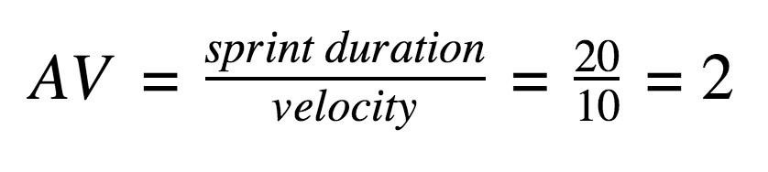

# BURNDOWN CHART

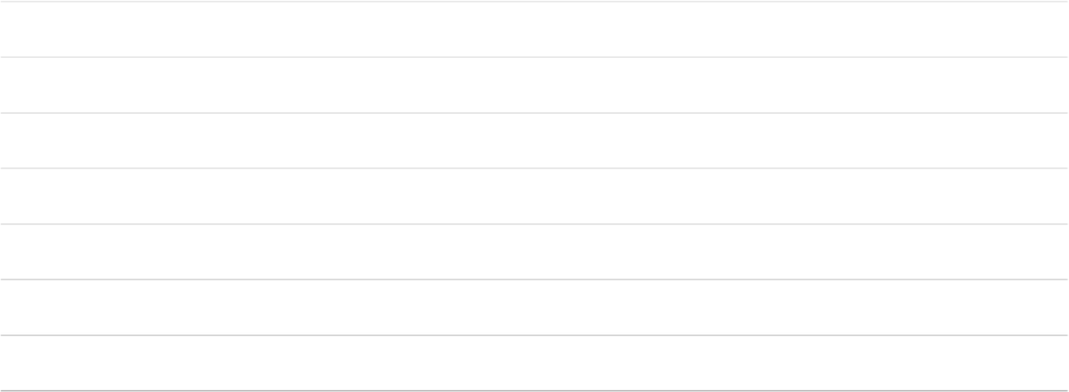

**70**

**42**

**25**

**13**

**8**

**80**

**66.66666667**

**53.33333333**

**40**

**26.66666667**

**13.33333333**

**0**

DAY 0

DAY 1

DAY 2

DAY 3

DAY 4

DAY 5

DAY 6

**BurntDown Chart**

remaining effort

ideal effort